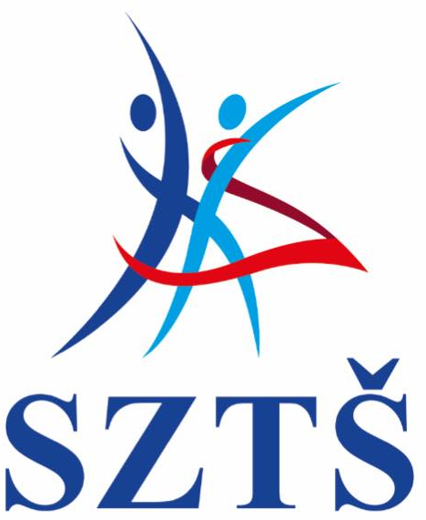
Slovenský zväz tanečného športu
Slovak dance sport federation *
Škultétyho 1, 83103 Bratislava, Slovakia
*člen /member of WDSF, SOV, KŠZ SR

To all WDSF Members,
Dear Ladies and Gentlemen,
We have a great pleasure to invite two couples from your country to following competitions:

2018 WDSF WORLD CHAMPIONSHIP SHOW DANCE STANDARD ADULT- BRATISLAVA,
22 September 2018 (two best nominated couples)
2018 WDSF WORLD CHAMPIONSHIP SHOW DANCE LATIN ADULT- BRATISLAVA,
22 September 2018 (two best nominated couples)
TANDARD ADULT- BRATISLAVA, 22 September 2018
Date: 22 September 2018

Place: Národné tenisové centrum, Príkopová 6, 831 03 Bratislava, Slovakia
Discipline: Show Dance Standard Adult
Show Dance Latin Adult
Expected competition schedule:
21.9. 2018- Obligatory rehearsal !!! ( participation of all couples is obligatory; exact timetable of the floor-tryout and rehearsal under the supervision of a chairperson will be announced after the entry deadline...Expected time of the rehearsal beginning is at 12 a.m.).
Program of the competiton: Saturday, 22.9.2018 - preliminary rounds app. 3 p.m.
- final rounds in Evening Gala from 7 p.m.

Organiser: Slovak Dance Sport Federation- SDSF
Škultétyho 1, Bratislava 83103, Slovakia, Tel.: +421/ 2/ 4445 7850, E-mail: szts@szts.sk
Local organisers: KTC Bratislava, TŠK M+M Bratislava pri ZŠ Ostredková, TK UNI-DANCE Bratislava
Accommodation: Aston Business Hotel, Bajkalská 22, 821 09 Bratislava
General conditions: Travel expenses must be paid by the couple.

Hotel accommodation: - double room with breakfast included up to 2 nights (21.9.- 23.9. 2018)- paid by organiser
- overseas competitors (America, Africa, China, Asia, Australia)- one night extra
20-21.9.2018 paid by organiser

Shuttle transfer: Bratislava/ Vienna airport to partner hotel – paid by organiser
Shuttle from/to hotel/comp. venue to /from comp. venue/hotel also provided by organiser
Judges: 12 judges nominated by WDSF (Absolute Judging System)
Entry: free entry for competitors (entry form must be filled)
Entry tickets: www.soch.sk

Please fill attached entry form including MIN WDSF (“member ID number”, number that identifies You as WDSF athlete )! Please return back to szts@szts.sk until 15 th August 2018.
Attached you can find very important document- manual of the new WDSF rules for WDSF show dance competitions as original version of the rules as well- please check your show program according to these rules. Based on the AGM WDSF 2018 in Laussane decree there will be accepted orginal rules (published on the WDSF website) as well as the inovated rules (icluded the inovations approved in AGM 2018).For better understanding you can find both documents attached in annex of this e-mail.

We hope the invitation will be accepted, so we would much appreciate your acceptance and request your notice in appropriate time.

For further information please check www.soch.sk

Petr Horáček
President of SDSF

