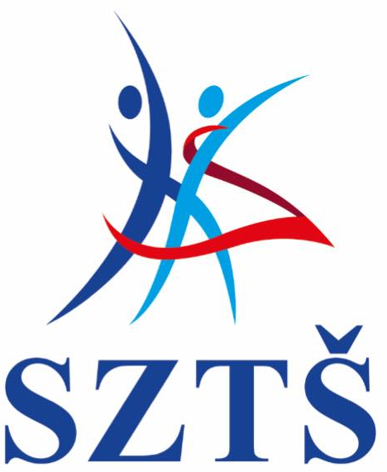
Slovenský zväz tanečného športu
Slovak dance sport federation *
Škultétyho 1, 83103 Bratislava, Slovakia
*člen /member of WDSF, SOV, KŠZ SR

To all WDSF Members,
Dear Ladies and Gentlemen,
We would like to give you additional informations to following competitions:

2018 WDSF WORLD CHAMPIONSHIP SHOW DANCE STANDARD ADULT- BRATISLAVA,
22 September 2018
2018 WDSF WORLD CHAMPIONSHIP SHOW DANCE LATIN ADULT- BRATISLAVA,
22 September 2018

Please be aware:
- Attached in annex you can find a revised version of the ENTRY FORM for the couples.

- We would like to put in attention and remind you that the music for your showdance has to be sent together with ENTRY FORM as Mp3 or Mp4.

- To enter to this World Championship is possible only through National Member Bodies.

Sincerely,

Petr Horáček
President of SDSF

