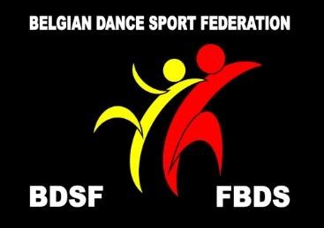 | Belgian Dance sport Federation ∙  BDSF Office  office@bdsf.be ∙ www.bdsf.be

To all WDSF Member Federations, 31 /8/2019
Dear Ladies and Gentlemen,

We have the great pleasure to invite your Sen I couples to

2020 World Dance Sport Federation – WDSF
SEN I OPEN WORLD CHAMPIONSHIP Standard

Date : Friday 07th February, 2020
Place BELGIUM, ANTWERP (Berchem)
Sporthal Het Rooi
Berchemstadionstraat 73

Organizers: Belgium Dance Sport Federation (BDSF) vzw
www.bdsf.be – E-mail: office@bdsf.be
Organizing club: Koninklijke Metropolis Danssport Club vzw – Karina & Jan Geerts
president Mr. Louis Cornelissens
www.antwerpdiamondcup.be – karina.geerts@skynet.be

Eligible participants:
All couples, of the competitive category of a WDSF Member body, are eligible to participate but a couple´s application for entry may only be made by the relevant WDSF Member body

Judges: nominated by WDSF

Entry: Please send your entry (use information as per the attached entry form) till 15 January 2020, directly to the BDSF federation
Hubert De Maesschalck-Director Standard/Latin Department BDSF
office@bdsf.be
Travel information: Arrival National Airport Brussels
Bus goes in 2 direction : Brussels Airport to Antwerp
Follow the indication in the airport terminal.
Departure Platform B at the bus station (level 0)
stop at Antwerp South (in front of Crowne Plaza)
stop at in Antwerp City Centre (De Keyzerlei ,near Central Station)
Tickets one way, sold by bus driver €10 - travel time 45 ‘
www.airportexpress.be (for time table departure hour bus)
- take attention last departure from airport is 0:00
Departure Antwerp to Brussel Airport
please check www.airportexpress.be (for time table departure hour bus)
on weekdays Monday to Saturday : first departure from 4:00
on Sunday first departure from 6:00
Airport Deurne : http://www.antwerp-airport.be
http://www.charleroi-airport.com/nl/brussels-south-charleroi-airport/
from here best to take rental car to come to Antwerp.

Hotel reservation: See website organization http://www.antwerpdiamondcup.be
For the hotel reservation and special prices (for deadline see website), use the reservation form available on the website.

Local Transport: Free shuttle bus from organizers hotel Crowne Plaza –
Departure and visa verso to the contest venue.

Special offer for coaches: Each participating country may nominate an official coach for the couple. The coach shall have a free entry to the hall on the day of the competition.

During the weekend other WDSF competitions will be organized, so we hope your couples will join and enjoy with us the whole weekend.

With best regards,
For BDSF,

Hubert De Maesschalck, Director Standard/Latin Department

